

**E commerce**

**For Cat sitting**

**student preparation:** Büşra Karabacak

2020/2021

Introduction

Web Design: It is the process of planning and executing multimedia content over the network (Internet), using patterns of technologies such as markup languages ​​suitable for display on Internet browsers or the rest of the user interfaces built in the Internet.

Web design is the creation of a web site (a collection of files placed side by side on one or more Internet servers), which allows content (including content and interactive interfaces) to be presented to the end user as a web page upon request that contains several elements such as:

Text, postal forms and bitmaps, all arranged by one of the languages ​​used, such as:

HTML, CSS, Java script.

# What is e-commerce?

e-commerce refers to the process of buying and selling goods an services online, though in recent years, and even more so during the pandemic, the shopping experience has extended beyond that.

**Benefits of running an e-commerce store:**

**24/7 shopping:** Most e-commerce websites allow shoppers to peruse products and make buying decisions at any time, day or night. This makes shopping easier for customers, and that kind of accessibility is a huge competitive advantage. As a business owner, this also allows you to bring in sales while you’re off doing something else (even while you’re sleeping).

**Meet customers where they are:** Having an online store gives you more channels to engage with customers. Integrate with social media and let people shop from their feed, help customers find you in Google searches and make purchases as as soon as they are ready, and send out newsletters to customers with products that they need based on their purchase history.

**Widened scope:** A physical store is limited to selling to customers who are in the area. Many e-commerce websites extend businesses to people all over the country or around the world, vastly expanding their customer base and potential revenue. Selling online also offers the ability to broaden or increase inventory — the number of items a business can sell online doesn’t need to be limited in the same way as a physical store, which might be a consideration to increase cash flow.

**Purchase-funnel clarity:** Currently, it’s nearly impossible to track how often a single customer comes to a physical store to browse before making a purchasing decision. However, an online store can track a customer’s every click, providing valuable insights into the purchasing process and paving the way for marketing opportunities (such as abandoned cart emails) to nudge customers who may be on the fence about purchasing.

Table of Contents

1-What is e-commerce? I

2-Introduction to web page design 1

2-1-What is a website: 1

2-2-……Web page 1

2-2-1-.What is the difference between HTML & HTML5? 1

2-2-2-.CSS (Cascading Style Sheet): 2

2-2-3-.Java Script programming language: 3

3-The practical section 6

3-1-Tools used (working platform & programming languages): 6

3-1-1-.Work Steps 6

4-References 11

Table of figures

**Figure( 1) Example of using a Slideshows 5**

**Figure( 2) Home Page 8**

**Figure( 3) contact us interface 9**

**Figure( 4) shopping cart 10**

**Figure( 5) Payment page 10**

# Introduction to web page design

With the great technical development that has taken place in recent years, and with the increasing need for communication on the Internet, electronic marketing and presentation of products in an easy and accessible way for everyone, the design of web pages has emerged, including communication sites, educational sites, entertainment sites, e-commerce sites and other useful sites.

## What is a website:

A website is a group of web pages that are linked together and stored on the same server.

Sites can be viewed by mobile phones via WAP technology.

Most websites have at least a start page that displays the content of that website and contains hyperlinks to its pages or to other website pages.

Each web page has a specific metric resource known as a URL (Uniform Resource Locator).

## Web page

A web page is:

A document or resource of information that is suitable for the World Wide Web, can be accessed through a web browser and displayed on a computer screen.

This information is usually in XHTML or CSC, and can provide access to other web pages via hyperlinks.

### What is the difference between HTML & HTML5?

To be able to compare the two languages ​​used to design the pages and what is the difference between them, we will talk about several axes and know each language and the differences and features of each one.

#### What is HTML?

Hypertext Markup Language (HTML) is the primary language of the World Wide Web.

It allows developers to design how web page elements, such as text, hyperlinks, and multimedia files, are displayed on the browser.

This language works statically, which means that you cannot create a dynamic or interactive web page feature with HTML.

It only modifies the static elements of the web page, such as the content header, footer, image position, etc.

To create a beautiful and interactive website, you need to integrate HTML with at least two front-end languages: Cascading Style Sheet (CSS) and JavaScript.

HTML uses various tags, including headings, tables, and paragraphs, to define the text structures on a page.

The first HTML was released in 1991 by Tim Berners-Lee. Its creation has seen many updates since then, including HTML 2.0 in 1995, HTML 3.2 in 1997, HTML 4.01 in 1999 and XHTML in 2000. Currently, the latest version of HTML is HTML5 released in 2014.

HTML5 has a large number of new additional features to its predecessors, such as support for offline media storage, more specific content elements (such as footer, header, navigation, etc.), a simpler embedded document type, and support for audio and video merging.

#### Key Features HTML5 Provides to Developers

HTML5 offers a transition for both developers and end users.

Some of the instructions provided by the finalists are:

Reduces mobile browser crashes.

It provides better dependence on email sites.

When a visitor wants to use the services of a particular company, you want to download it, just email in East Commerce. Give developers an aesthetically rich user experience with JavaScript and MPEG4. Support for audio and video elements without any plug-in.

### CSS (Cascading Style Sheet):

#### What is CSS?

CSS is an acronym for Cascading Style Sheet, a descriptive language that gives a website its beautiful look and unique design that will distinguish it from other websites.

The CSS language is friendly to the HTML language, as it is always accompanying it and beside it in the design and creation of web pages.

Both of these languages ​​form the basis of every website, HTML is the basis of all web page elements, and CSS is the basis for the design and appearance of the site. Without it, websites would remain plain text on white backgrounds.

Before CSS was started in 1996 by the World Wide Web Consortium (W3C), web pages were very limited and simple in form and function.

Old browsers used to display web pages as pages consisting of black text with a white background only (text - images - links, etc.) without any design.

There was no planning for the date of the launch of the CSS language.

CSS has allowed web pages to be designed and structured in many different ways to be able to capture how creative a person is, such as the ability to:

Determine the lines, margins, and distances for the elements of the site.

Determine the color and size of the elements.

Apply colors to backgrounds.

Move the elements freely and get many movements in the site.

And many other advantages.

Microsoft Internet Explorer 3 was the first browser in which CSS was introduced and used in 1998. Today, support for some CSS features varies from browser to browser. The W3C, which still oversees and defines web standards, has released a new CSS standard or version, CSS3. With the release of CSS3, developers hope that all major browsers will read and display every CSS feature in the same way.

#### How does CSS work?

To understand the basics of how CSS works, you must first understand a little bit about HTML. Which we talked about earlier, where the elements of web pages are units on square shapes, each of which contains many elements, and its size and shape are customized by the CSS language.

For example, the header is a square, and it contains many other smaller modules that include all the elements that make up the header, such as the logo, the Navbar, the social icons and so on. With CSS, the developer customizes the look and size to the header.

#### What is the difference between CSS and HTML?

**Language (HTML):**

1. It is a language used in the formation of websites completely, and is considered the main part in websites and web applications and is used in developing a structure and a logical system for the contents.

2. It is easy to learn.

3. Marking technology is used.

4. HTML files can include CSS codes.

5. Responsible for uploading anything on the website pages and is responsible for the links (LINKS).

**For CSS language:**

1. They are used to add styling to these contents.

2. It creates some complexities in the code.

3. Delimiters are used.

4. This language does not include HTML in its code

5. It controls the general appearance of the website and helps to make the website appear in the most beautiful way.

### Java Script programming language:

It is a programming language that adds custom interaction and behaviors to a site.

It is a client-side scripting language, which means that it runs on the user's machine and not on the server, like other web programming languages ​​like PHP and Ruby, meaning that JavaScript (the way we use it) depends on the capabilities and settings of the browser.

It might not be available at all, either because the user chose to turn it off or because the device doesn't support it, something that good developers keep in mind and plan for.

It is also known as a dynamic and loosely typed programming language.

The name is very confusing, even though its name is JavaScript that has nothing to do with Java. It was created by Brendan Eich at Netscape in 1995 and was originally called live script but Java was ubiquitous at the time. For marketing, it became Live Script JavaScript or (JS) only.

#### What can JavaScript do?

Most commonly we will encounter JavaScript as a way to add interactivity to a page file.

Where the page's 'structural' layer is our markup and the page's 'structural' layer consists of CSS, then the third 'behavioral' layer is our JavaScript. All elements, attributes, and scripts on a web page can be accessed via scripts using the DOM Document Object Model.

Use javaScript.

We can also write scripts that react to user input, change page contents, CSS styles, or browser behavior on the fly. You've likely seen this in practice if you've tried to register on the website, enter a username, and immediately receive feedback that the name The user you entered is already used by someone else (Figure 5).

Red border around text input and "sorry" appears, this username is already in use "The message is examples of JavaScript modification of the page's contents file, form submission blocking is an example of JavaScript changing the default behavior of the browser.

#### Summary of the benefits of the Java Script:

The capabilities of JavaScript cannot be limited to a few lines, but as it has been said, it has amazing capabilities that appear in the JQuery library in the Ajax service, which is to communicate with the server without reloading the page.

But in short, the practical importance of JavaScript for the user is that it is used as Client Side Processing. For example, we have a table and we want to do a search with it. This can be done on the server through a specific query, and if the whole table is visible to the user, the table can be sorted and searched.

Interaction with the user does not stop there, but also Slideshows and Galleries that you can design through JavaScript, and this is also an example of Slideshow.

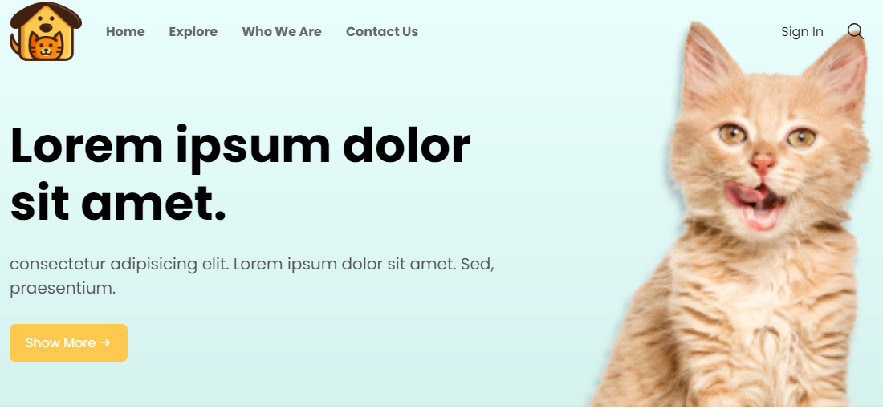

Figure( 1) Example of using a Slideshows

And we have another vivid example, which is Facebook. For example, the right menu in which users’ updates appears. When you click on an update, a box with more data appears for you, and you can interact and put a comment through it, when you click on an image and you find it grows in front of you in a black window.

**One of the most important uses of JavaScript is also the use of the API for websites:**

Definition of API: An Application Programming Interface (API) is a set of routines, data structures, data algorithm object classes, and/or protocols provided by libraries and/or operating system services to support building programs.

In short, it is a library provided by a site to you to benefit from its services in building your site. Some simple examples. You built a site to sell some products and you want to allow the user to buy your products through Paypal. How will you provide that service to him? Simply through the API provided to you by Paypal. You have a site and you want to allow the user to log in through Facebook or Google. You can perform this process simply through the API. You have a statistic that you want to display and format in an acceptable manner through an interactive chart, Google Provides you with an API to facilitate the work of the Chart.

Summarizing what was said, JavaScript has a very large and important potential and has become essential in any modern website. In order to master it, you must start with the basics such as variables and if, loops and can be used in:

1- Interactive elements with the user.

2- The API.

# The practical section

## Tools used (working platform & programming languages):

**Sublime Text:** It was used as a code editor to create and design the website.

**Google Chrome:** It was used as a browser to display the changes taking place during the design of the site, and during the project implementation stages step by step to know and ensure the effectiveness of the tools used.

**Programming languages:** HTML, CSS, JAVA SCRIPT.

### Work Steps

#### Equip working platform:

Sublime Text Editor: Easy to handle in addition to being available and free and meets the purpose.

Google Chrome: It is found in almost all devices.

#### Built main and subpages:

**Home**: It is the main interface that appears to the user upon first accessing the site

It contains:

- Some animated cat pictures available in the store.

- An interface through which the user can search for the right cat through categories

Interface to browse all cats.

Figure( 2) Home Page

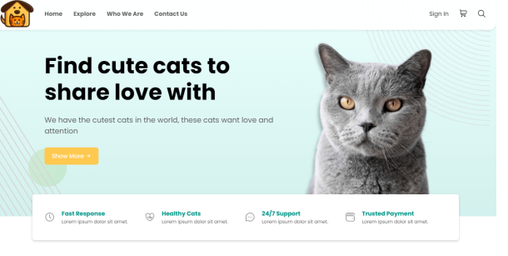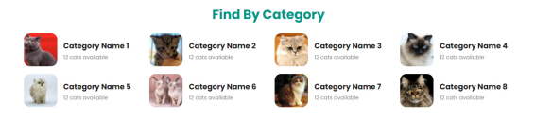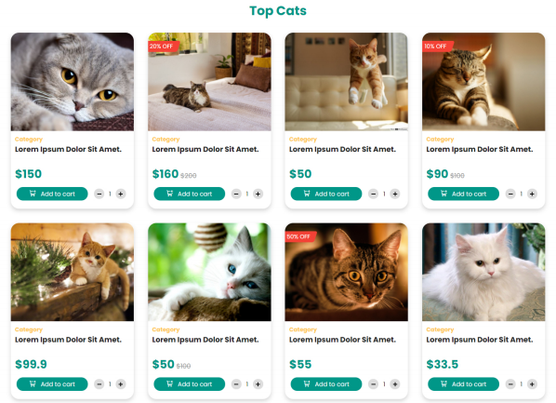

**Explore**: user can search for the right cat through categories Interface to browse all cats.

**Who we are:** It contains information about the affiliate of the site and contact information with the company from the email and phone number

**Sign in:** To log in to the site.

**Contact us:** It has the following interface

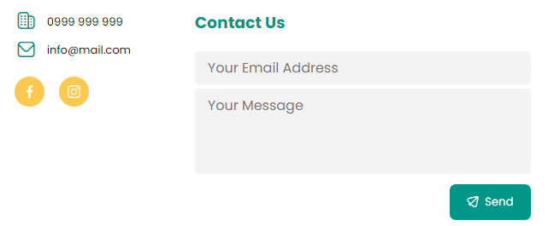

Figure( 3) contact us interface

#### Another pages

the shopping cart that contains information about the purchased cats and their price, in addition to the possibility of reducing and increasing the number of purchases.

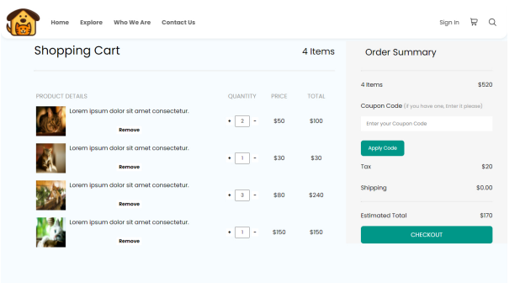

Figure( 4) shopping cart

payment sub-interface that contains the following components:

* The name
* Address
* City
* Postal code
* mobile number

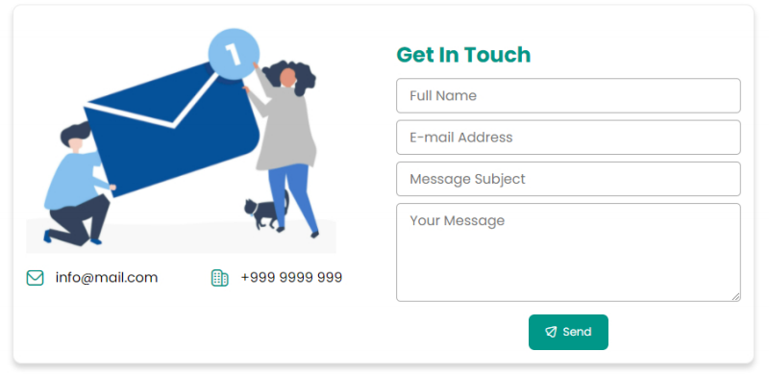

**+49 95653431287**

Figure( 5) Payment page

# References

|  |  |
| --- | --- |
| [1] | M. J. N. a. N. Peterson, LEARN TO CODE HTML & CSS: DEVELOP & STYLE WEBSITES, 2014. |
| [2] | Dr. Jon Smith, INTRODUCTION TO THE INTERNET, 2009. |

3] https://www.google.com/search?q=%D8%B5%D9%88%D8%B1+%D9%82%D8%B7%D8%B7&client=firefox-b-d&tbm=isch&source=iu&ictx=1&fir=YV40rFbrm5iZgM%252Cpv7ItwjziaTuHM%252C_&vet=1&usg=AI4_-kS4kfEFY9FFLHSY5ir-5Ps6f6Kabw&sa=X&ved=2ahUKEwjlr7_RnO7xAhVdBGMBHc3jDDUQ9QF6BAgVEAE&biw=1366&bih=643#imgrc=YV40rFbrm5iZgM